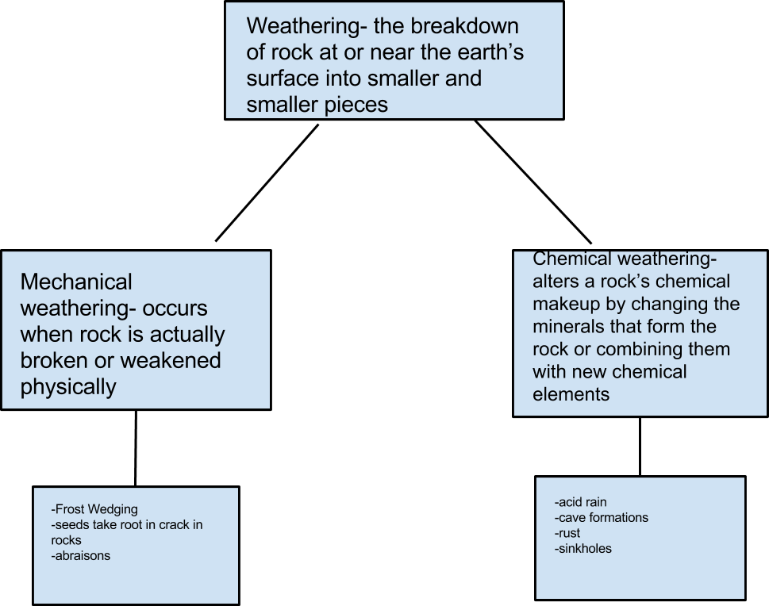

Directions: With a partner fill out the following charts that correlate to Section 3.

In Chart 1 fill in details for Weathering. The top box should be the word weathering, the two connecting to it should be the two types of weathering, and the bottom two boxes will be a place to put examples of each type of weathering.

Following completion of this chart, move onto Chart 2 That chart will be for defining the word Erosion and then filling in the types of examples of each type of erosion that occurs. Again, like in the chart above, once you have identified the three types of erosion discussed, fill in examples in the boxes below each type.

